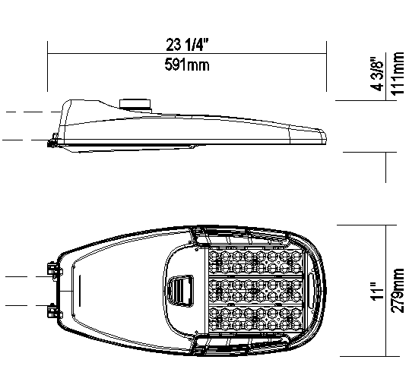

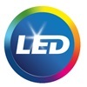

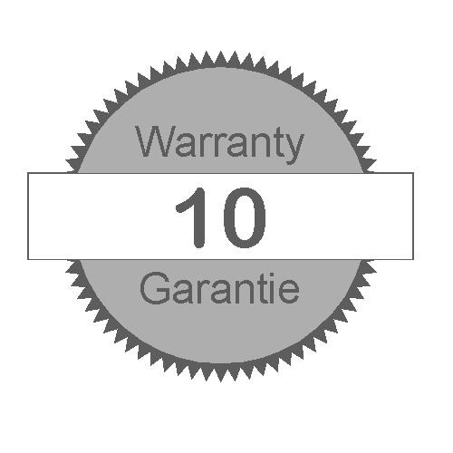


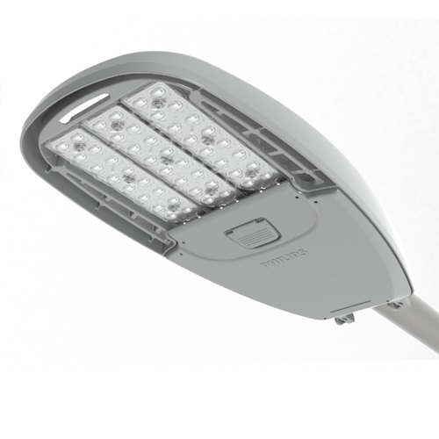

EPA: 0.523 sq ft / weight: 12.3 lb (5.6 kg)
Note: 3D image may not represent color or option selected.
Logos above include link, click to access.

Qty | 40 | Luminaire RFM-108W48LED4K-G2-R3M-UNV-DMG-FAWS-RCD7-SP2-GY3

Description of Components:

Housing: Made of a low copper die cast Aluminum alloy (A360), 0.100" (2.5mm) minimum thickness. Fits on a 1.66" (42mm) O.D. (1.25" NPS), 1.9" (48mm) O.D. (1.5" NPS) or 2 3/8" (60mm) O.D. (2" NPS) by 5 1/2" (140mm) minimum long tenon. Comes with a zinc plated clamp fixed by 2 zinc plated hexagonal bolts 3/8 16 UNC for ease of installation. Provides an easy step adjustment of +/- 5° tilt in 2.5º increments. Includes integral bubble level standard (always included). A quick release, tool less entry, single latch, hinged, removable door opens downward to provide access to electronic components and to a terminal block. Door is secured to prevent accidental dropping or disengagement. A clearance of 13" (330mm) at the rear is required in order to remove the door. Complete with a bird guard protecting against birds and similar intruders and an ANSI label as per C136.15-2020 to identify wattage and source (both included in box).

Light Engine: Composed of 4 main components: Heat Sink / LED Module / Optical System / Driver
Electrical components are RoHS compliant, IP66 sealed light engine.
LEDs tested by ISO 17025-2005 accredited lab in accordance with IESNA LM-80 guidelines, extrapolations in accordance with IESNA TM-21. Metal core board ensures greater heat transfer and longer lifespan.

Heat Sink: Built in the housing, designed to ensure high efficacy and superior cooling by natural vertical convection air flow pattern always close to LEDs and driver optimising their efficiency and life. Product does not use any cooling device with moving parts (only passive cooling). Wide openings enable natural cleaning and removal of dirt and debris. Entire luminaire is rated for operation in ambient temperature of -40°C / -40°F up to +50°C / +122°F.

LED Module: Composed of 48 high-performance white LEDs. Color temperature as per ANSI/NEMA bin Neutral White, 4000 Kelvin nominal (3985K +/- 275K or 3710K to 4260K), CRI 70 Min. 75 Typical.

Optical System: (R3M), IES type III medium (asymmetrical). Composed of high-performance UV stabilized optical grade polymer refractor lenses to achieve desired distribution optimized to get maximum spacing, target lumens and a superior lighting uniformity. System is rated IP66. Performance shall be tested per LM-63, LM-79 and TM-15 (IESNA) certifying its photometric performance.0% uplight and U0 per IESNA TM-15.

Driver: High power factor of 90% min. electronic driver, operating range 50/60 Hz. Auto-adjusting universal voltage input from 120 to 277 VAC rated for both application line to line or line to neutral, THD of 20% max. Driver comes with dimming compatible 0-10 volts.

The current supplying the LEDs will be reduced by the driver if the driver experiences internal overheating as a protection to the LEDs and the electrical components. Output is protected from short circuits, voltage overload and current overload. Automatic recovery after correction.

Driver Options: (DMG) Integrated Feature, Dimming compatible 0-10 volts. For applicable warranty, certification and operation guide see Lumec dimmable luminaire specification document for unapproved device installed by other. To get document, click on this link: Specification document or go on web site on this address: https://www.signify.com/b-dam/signify/en-us/brands/lumec/Lumec-un-approved-control-device-installed-by-others-7_d.pdf

Surge Protector: (SP2), Integral surge protector tested in accordance with ANSI/IEEE C62.45 per ANSI/IEEE C62.41.2 Scenario I Category C High Exposure with elevated 20kV/10kA waveforms for Line-Ground, Line-Neutral and Neutral-Ground, and in accordance with U.S. DOE (Department of Energy) MSSLC (Municipal Solid-State Street Lighting Consortium) model specification for LED roadway luminaires electrical immunity requirements for High Test Level 10kV/10kA.

Luminaire Options: (FAWS), Field Adjustable Wattage Selector, pre-set to the highest position, can be easily switched in the field to the required position. This reduces total luminaire wattage consumption and reduces the light level - see the FAWS multiplier chart for more details. Note: It is not recommended to use FAWS with other dimming or controls; if you do, set the switch to position 10 (maximum output) to enable the other dimming or controls. Switching FAWS to any position other than 10 will disable the other dimming or controls. (RCD7), Receptacle with 7 pins enabling dimming and with two extra connections for future use (these connections are capped off at the factory - requires connections to be made in the field), can be used with a twist-lock control device or photoelectric cell or a shorting cap. Use of photocell or shorting cap is required to ensure proper illumination.

Luminaire Useful Life: Refer to IES files for energy consumption and delivered lumens for each option. Based on ISTMT in-situ thermal testing in accordance with UL1598 and UL8750, System Reliability Tool. Advance data and LED manufacturer LM-80/TM-21 data, expected to reach 100,000 + hours with >L70 lumen maintenance @ 25°C. Luminaire Useful Life accounts for LED lumen maintenance AND all of these additional factors including: LED life, driver life, PCB substrate, solder joints, on/off cycles, burning hours and corrosion.

Miscellaneous

Description of Components:

Wiring: The connection of the luminaire is done using a terminal block connector 600V, 85A for use with #2-14 AWG. wires from the primary circuit, located inside the housing. Due to the inrush current that occurs with electronic drivers, recommend using a 10Amp time delay fuse to avoid unwanted fuse blowing (false tripping) that can occur with normal or fast acting fuses.

Hardware: All exposed screws shall be complete with Ceramic primer-seal basecoat to reduce seizing of the parts and offers a high resistance to corrosion. All seals and sealing devices are made and/or lined with EPDM and/or silicone and/or rubber.

Finish: Color to be medium grey (GY3) and in accordance with the AAMA 2603 standard. Application of polyester powder coat paint (4 mils/100 microns) with ± 1 mils/24 microns of tolerance. The Thermosetting resins provides a discoloration resistant finish in accordance with the ASTM D2244 standard, as well as luster retention in keeping with the ASTM D523 standard and humidity proof in accordance with the ASTM D2247 standard.

The surface treatment achieves a minimum of 5000 hours for salt spray resistant finish in accordance with testing performed and per ASTM B117 standard.

LED products manufacturing standard: The electronic components sensitive to electrostatic discharge (ESD) such as light emitting diodes (LEDs) are assembled in compliance with IEC61340-5-1 and ANSI/ESD S20.20 standards so as to eliminate ESD events that could decrease the useful life of the product.

Vibration Resistance: The RFM meets the ANSI C136.31, 2010, American National Standard for Roadway Luminaire Vibration specifications for Bridge/overpass applications (Tested 3G over 100 000 cycles).

The RFM meets the California Test 611, Testing durability of mast arm mounted luminaires, specifications (a 2 000 000 cycles test).

Service Tag: Each individual luminaire is uniquely identifiable, thanks to the Service tag application. With a simple scan of a QR code, placed on the inside of the mast door, you gain instant access to the luminaire configuration, making installation and maintenance operations faster and easier, no matter what stage of the luminaire’s lifetime. Just download the APP and register your product right away. For more details visit: Signify.com/servicetag

Warranty: Luminaire comes with a warranty of 10 years on product and finish.

Certifications and Compliance: cULus Listed for Canada and USA. Luminaire meets DOE and MSSLC Model Specification for LED Roadway Luminaires. Medium RoadFocus LED Cobra head luminaires are DesignLights Consortium qualified, consult DLC QPL to confirm your specific fixture selection is approved. Luminaire complies with or exceeds the following ANSI C136 standards: .2, .3, .10, .14, .15, .22, .25, .31, .37, .41.

Web site information details: Click on any specific information details you need: / cULus Certification

